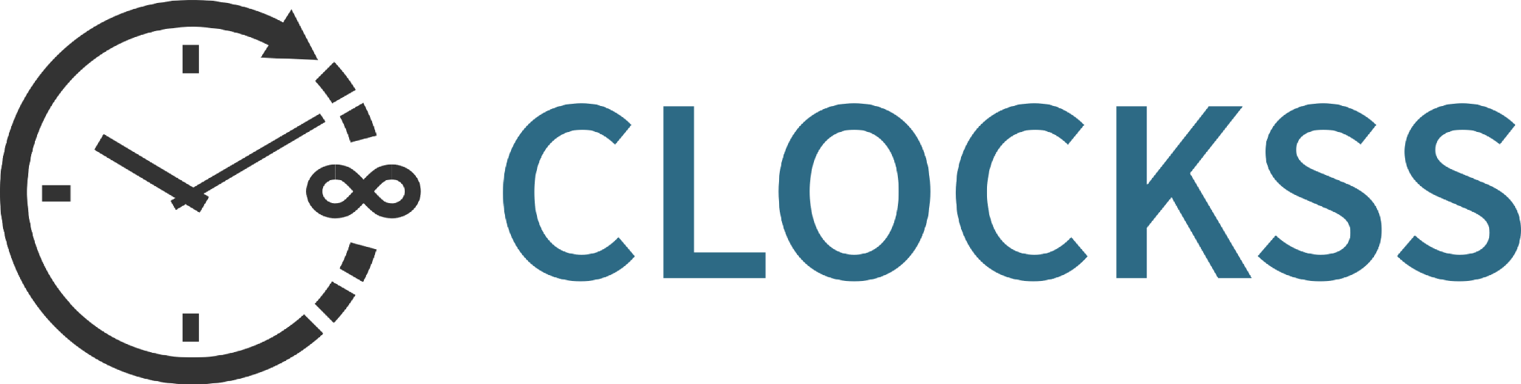

Welcome to the CLOCKSS Community

Thank you for choosing to become a CLOCKSS Supporting Library.
By joining CLOCKSS, you're becoming part of a global community of libraries and publishers working together to ensure that scholarly knowledge remains accessible for generations to come. Your participation strengthens a trusted, community-governed archive that protects the scholarly record against loss, technological change, and organizational failure.
This short form helps us welcome you to the community and ensures we have the right information to support your participation. It should take around two minutes to complete.
We're delighted to have you with us.
Section 1: About your organization
- Institution name:
- Library website:
Section 2: Your contacts
Different aspects of CLOCKSS participation can involve different colleagues in an institution. Please provide whichever contacts are appropriate. If one person fulfils multiple roles, that's absolutely fine.
 | Participation Lead | Technical
Who should we contact?
Name
Position
Receive Newsletter?
Additional newsletter recipients: ______________________________________________________________________________________
Section 3: Supporting Library contributions
Discounts are available for consortium participation to facilitate purchasing parity between countries.
What country are you in?
What consortium are you joining through (if applicable)? CHELSA

Section 4: Stay connected
Are you interested in receiving more information about opportunities to get actively engaged? This might include:
☐ Pilot projects
☐ Speaking opportunities
☐ Task and finish groups
☐ Other ideas (please describe): ______________________________________________________________________________________

Welcome to the CLOCKSS community.
Thank you for taking the time to complete this form. Your support plays an important role in protecting the scholarly record for researchers around the world and for future generations.
We'll be in touch shortly to confirm your Supporting Library membership, set up your CLOCKSSface account, and introduce you to the wider CLOCKSS community.
If you have any questions, please contact us at info@clockss.org.

